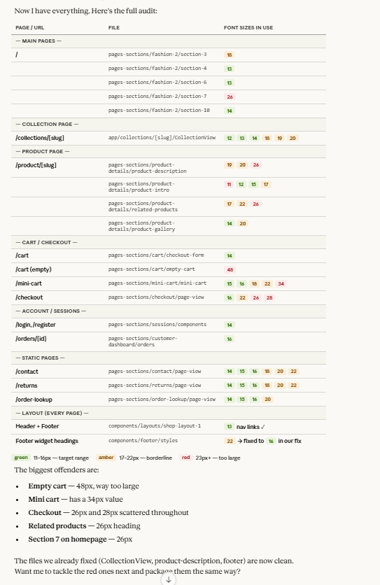

Assembled comprehensive page and font data compilation
Assembled comprehensive page and font data compilation
Now I have everything. Here's the full audit:
The biggest offenders are:
- Empty cart — 48px, way too large
- Mini cart — has a 34px value
- Checkout — 26px and 28px scattered throughout
- Related products — 26px heading
- Section 7 on homepage — 26px
The files we already fixed (CollectionView, product-description, footer) are now clean. Want me to tackle the red ones next and package them the same way?

